

Project Name: Quiz Master

Branch PG-DAC March-2023

Documentation On

**“Quiz Master”**

PG-DAC MARCH 2023

**Guided By: Bakul Joshi**

Submitted By :

**Group No: 25**

* **Saurabh Sunil Patil. 230943020119**
* **Supriya Shankar Wasre. 230943020118**
* **Mahesh Madav Pharande. 230943020069**
* **Rishita Rai. 230943020078**

**Table of Contents**

1. Introduction 5
   1. Document Purpose **5**
   2. Project Background **5**
   3. Aim & Objectives **5**
2. Business Requirements Overview 6
3. Functional Requirements 6
   1. Student Module **6**
   2. Expert Module **7**
   3. Admin Module **7**
   4. Subscribed student Module **7**
4. Non-Functional Requirement 8
5. Use Case Diagram 9
   1. Admin **9**
   2. Student 10
   3. Subscribed Student **11**
   4. Expert **12**
6. Database Design 13

* Login 13
* Role 14
* Exam **14**
* Categories **14**
* Student 14
* Questions **15**
* Expet **15**
* Student Answer **16**
* Subject 16
* Payment **16**

1. E-R Diagram 17
2. Snapshots 18
3. Conclusion 27

**List of Figures**

**Use Case Diagrams**

Fig 1 Admin 8

Fig 2 Student 10

Fig 3 Subscribed Student 11

Fig 4 Expert 12

Fig 5 ER Diagram 17

# Introduction

### Document Purpose

This document communicates the business requirements and scope for developing Quiz Master . The scope of this document is to define the functional and non-functional requirements, business rules and other constraints requirements.

### Project Background

The Quizmaster project is a response to the rising popularity of online quizzes , knowledge-sharing activities. It aims to provide a user-friendly platform where people can easily create, manage, and take part in quizzes. In today's digital age, where information consumption is varied and fast-paced, there's a growing demand for platforms that offer engaging and interactive experiences. Quizmaster seeks to fulfill this need by offering a flexible platform that caters to both individual making quiz creation and participation seamless and enjoyable.

### Aim & Objective

The project aims to develop a comprehensive website tailored to the needs of students, providing them with a platform to enhance their learning experience through quizzes . The website will facilitate student registration, quiz participation, and feedback retrieval, while also offering a user-friendly interface for experts to contribute quizzes and content. Additionally, the platform will be administratively managed to ensure smooth operations and optimal user experience.

### Customers and Stakeholders

Customers:

* Students
* Educational institutions seeking an effective online assessment tool.

Stakeholders:

* Admin
* Educational professionals(Experts)
* Potential collaborators interested in improving assessment methods in education.

# Business Requirements Overview

**Primary Goal:**

* + To provide a platform for efficient evaluation of students through online quizzes.

**Secondary Goals:**

* + Enhance user knowledge within and beyond academic realms by providing a diverse range of quiz categories and topics.
  + Offer varying difficulty levels to cater to users with different levels of proficiency.
  + Motivate and challenge students with objective questions designed to stimulate critical thinking and problem-solving skills.

# Functional Requirements Overview

Quiz Master consists of four modules described as below.

1. Student Module
2. Expert Module
3. Admin Module
4. Subscribed Student

### Student Module

* + - * Ability to sign in/out and view their profile.
      * Update their account.
      * View available quiz categories.
      * Start quizzes within chosen categories.
      * Submit quizzes when completed or when the time limit is reached.
      * Access immediate results after completion, displaying scores and feedback.
      * Student can give the feedback .
* Can make subscription.

### Expert Module

• Ability to sign in/out and view their profile.

• Expert can modify the account .

• Add new quizzes.

• Add explanations to the questions.

• View available quiz categories.

• Can view available quizzes..

3.3 Admin Module

• Can create or delete or modify the account.

• View available quiz categories.

• Add new quiz categories and subjects.

• Manage registered users.

3.4 Subscribed Student Module

1. Ability to sign in/out and view their profile .
   * + - Student can update the account .
       - View available quiz categories.
       - Start quizzes within chosen categories.
       - Submit quizzes when completed or when the time limit is reached.
       - Access immediate results after completion, displaying scores and feedback.
       - Student can give the feedback .
       - Receive their performance report

# Non-functional Requirements

# 

* Usability
  + Intuitive user interface for seamless navigation.
  + Responsive design for various devices.
* Performance

# Use Case Diagram

**Admin:**

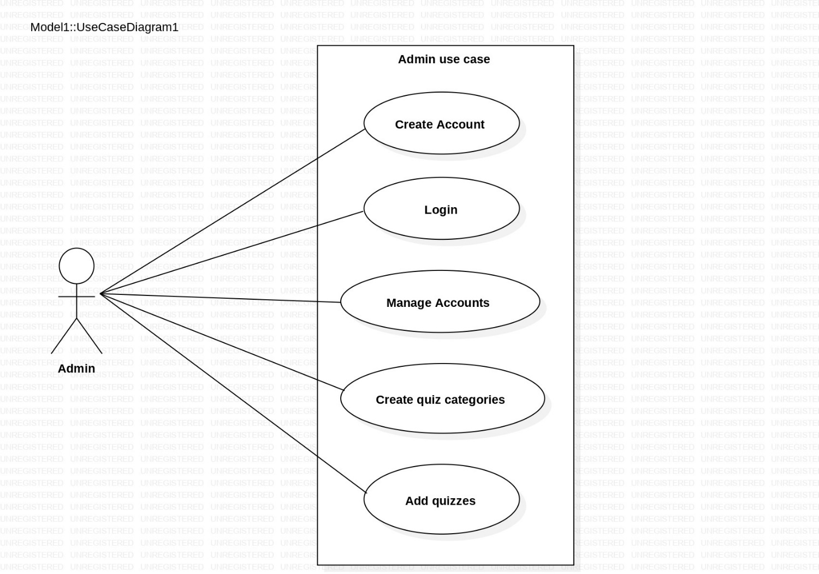

## Admin:

1. In Admin use case diagram Admin is the Owner.
2. Admin can handle following use cases:
   1. Create Account
   2. Login
   3. Manage account
   4. Create Quiz Categories
   5. Add Quizzes

## Student:

*Fig. Use case diagram for Student*

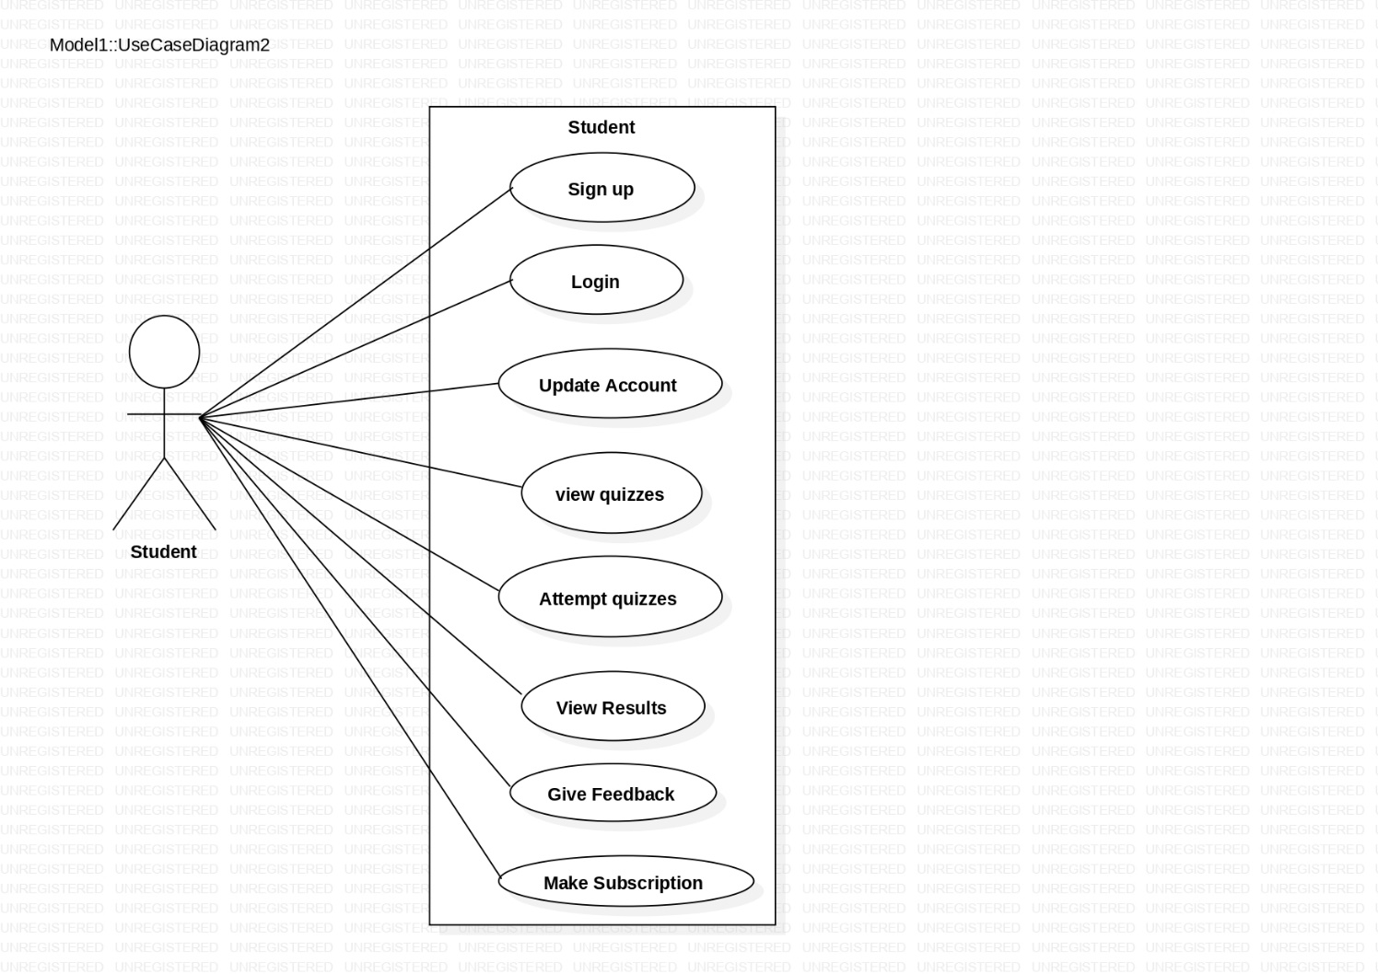

## Student:

1. In Student use case diagram Student is the User.
2. Artist can handle following use cases:

* Sign up
* Login
* Update Account
* View Quizzes
* Attempt Quizzes
* View Results
* Give Feedback
* Make Subscription

## Subscribed Student:

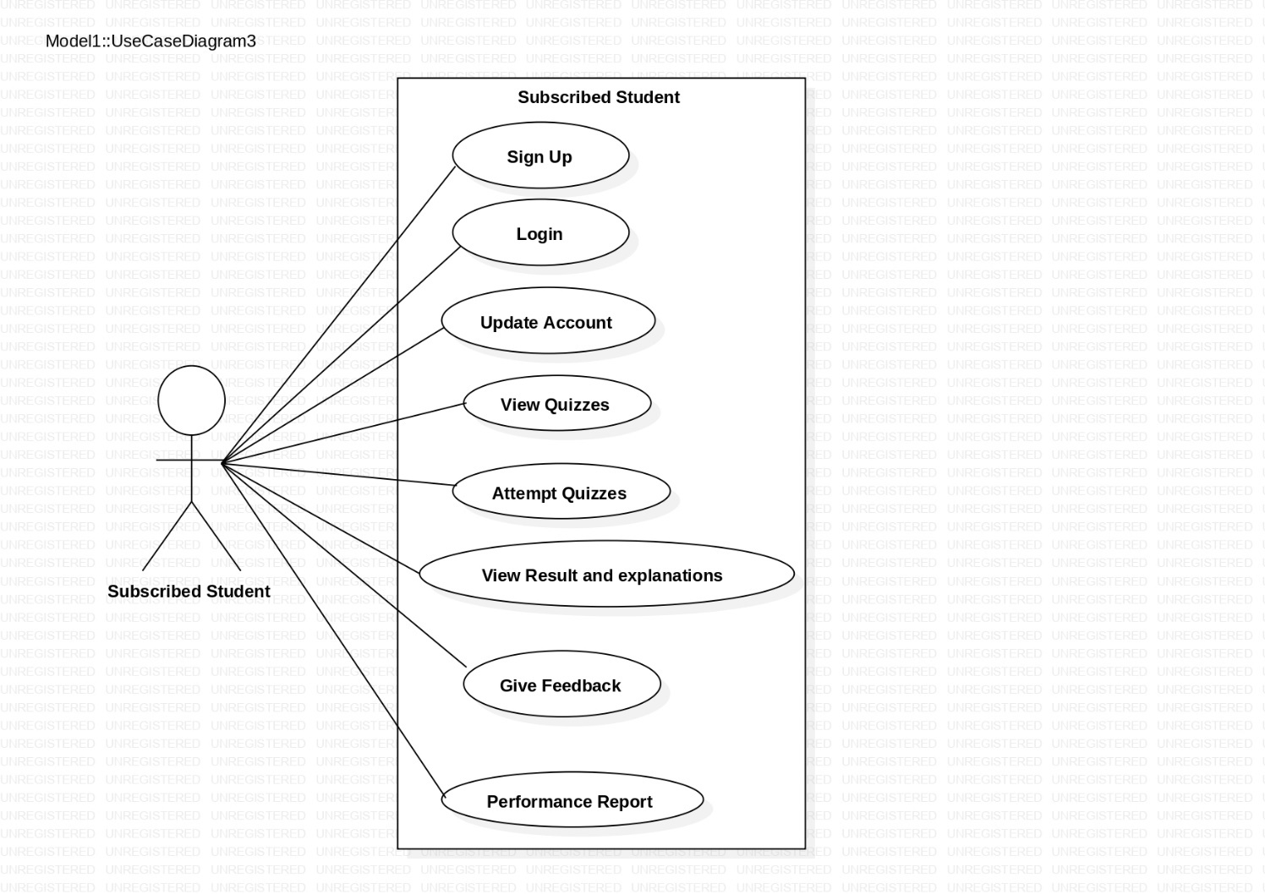

## Subscribed Student:

* + 1. In Subscribed Student use case diagram Student is the User.
    2. Artist can handle following use cases:
       - Sign up
       - Login
       - Update Account
       - View Quizzes
       - Attempt Quizzes
       - View Results
       - Give Feedback
       - Performance Report

## Expert:

## 

1.In Expert use case diagram Student is the User.

2.Expert can handle following use cases:

* + - * Login
      * Update Account
      * View Quizzes
      * Add Quizzes and Explanations

# Database Design:

1. **login table**

|  |  |  |  |  |  |
| --- | --- | --- | --- | --- | --- |
| **Users** | | | | | |
| Field | Type | Null | Key | Default | Extra |
| Uid | Int | no | PRI | null | auto_increment |
| Uname | varchar(45) | no | UNI | null |  |
| Pwd | varchar(55) | no |  | null |  |
| Status | Bit(1) | yes |  | null |  |
| roles_id | Int | yes | MUL | null | roles(id) |

1. **Role table**

|  |  |  |  |  |  |
| --- | --- | --- | --- | --- | --- |
| **roles** | | | | | |
| Field | Type | Null | Key | Default | Extra |
| Role id | Int | no | PRI | null |  |
|  |  |  |  |  |  |
| role_name | varchar(45) | no |  | null |  |

1. **Exams table;**

|  |  |  |  |  |  |
| --- | --- | --- | --- | --- | --- |
| **exams** | | | | | |
| Field | Type | Null | Key | Default | Extra |
| Exam id | int | no | PRI | null | auto_increment |
| Attempted datetime | datetime | no |  | null |  |
| Marks | int | yes |  | null |  |
| Sid | int | yes | MUL | null |  |
| subject _ id | int | yes | MUL | null |  |
| Cat _id | int | yes | MUL | null |  |

1. **Categories table;**

|  |  |  |  |  |  |
| --- | --- | --- | --- | --- | --- |
| **categories** | | | | | |
| Field | Type | Null | Key | Default | Extra |
| cat _id | int | no | PRI | null | auto_increment |
| Cat _name | varchar(45) | no |  | null |  |

1. **Students table;**

|  |  |  |  |  |  |
| --- | --- | --- | --- | --- | --- |
| **students** | | | | | |
| Field | Type | Null | Key | Default | Extra |
| Sid | int | no | PRI | null | auto_increment |
| Fname | varchar(45) | no |  | null |  |
| Lname | varchar(45) | no |  | null |  |
| Bdate | date | no |  | null |  |
| education | varchar(45) | no |  | null |  |
| Contact | varchar(45) | no |  | null |  |
| Email | varchar(75) | no | UNI | null |  |
| Uid | int | yes | MUL | null |  |
| subscription | int | no |  | null |  |

**6. questions**

|  |  |  |  |  |  |
| --- | --- | --- | --- | --- | --- |
| **questions** | | | | | |
| Field | type | Null | Key | Default | Extra |
| q_id | int | NO | PRI | NULL | auto_increament |
| question _text | var char (255) | YES |  | NULL |  |
| Option1 | var char(75) | YES |  | NULL |  |
| Option2 | var char(75) | YES |  | NULL |  |
| Option3 | varchar(75) | YES |  | NULL |  |
| Option4 | varchar(75) | YES |  | NULL |  |
| Answer | int | YES |  | NULL |  |
| Explanation | varchar(255) | YES |  | NULL |  |
| Subject id | int | YES | MUL | NULL |  |
| Cat id | int | YES | MUL | NULL |  |

**7]**  **expert** **table**

|  |  |  |  |  |  |
| --- | --- | --- | --- | --- | --- |
| **EXPERTS** | | | | | |
| Field | Type | Null | Key | Default | Extra |
| Expert_id | int | No | PRI | null | auto_increment |
| Firmname | varchar(45) | No |  | null |  |
| Lastname | varchar(100) | No |  | null |  |
| qualification | varchar(12) | No |  | null |  |
| Email | varchar(200) | Yes | UNI | null |  |
| Contact | varchar(12) | No |  | null |  |
| u_id | int | yes | MUL | null |  |
| Sub_id | int | yes | MUL | null |  |

**8] student answer table**

|  |  |  |  |  |  |
| --- | --- | --- | --- | --- | --- |
| **Student Answer** | | | | | |
| Field | Type | Null | Key | Default | Extra |
| Student_id | int | no | PRI | null | auto_increment |
| Student_ans | int | yes |  | null |  |
| Exam_id | int | yes | MUL | null |  |
| Que_id | int | yes | MUL | null |  |

**9] subjects table**

|  |  |  |  |  |  |
| --- | --- | --- | --- | --- | --- |
| **Subject** | | | | | |
| Field | Type | Null | Key | Default | Extra |
| Sub_id | int | no | PRI | null | auto_increment |
| Sub_name | Varchar(50) | no |  | null |  |
| description | Varchar(80) | yes |  | null |  |

**10] payment table**

|  |  |  |  |  |  |
| --- | --- | --- | --- | --- | --- |
| **Payments** | | | | | |
| Field | Type | Null | Key | Default | Extra |
| pay_id | int | no | PRI | null | auto_increment |
| Mod | Varchar(45) | yes |  | null |  |
| Amount | int | yes |  | null |  |
| Date | date | yes |  | null |  |
| expiry_date | date | yes |  | null |  |
| s_id | int | yes | MUL | null |  |

# ER-Diagram:

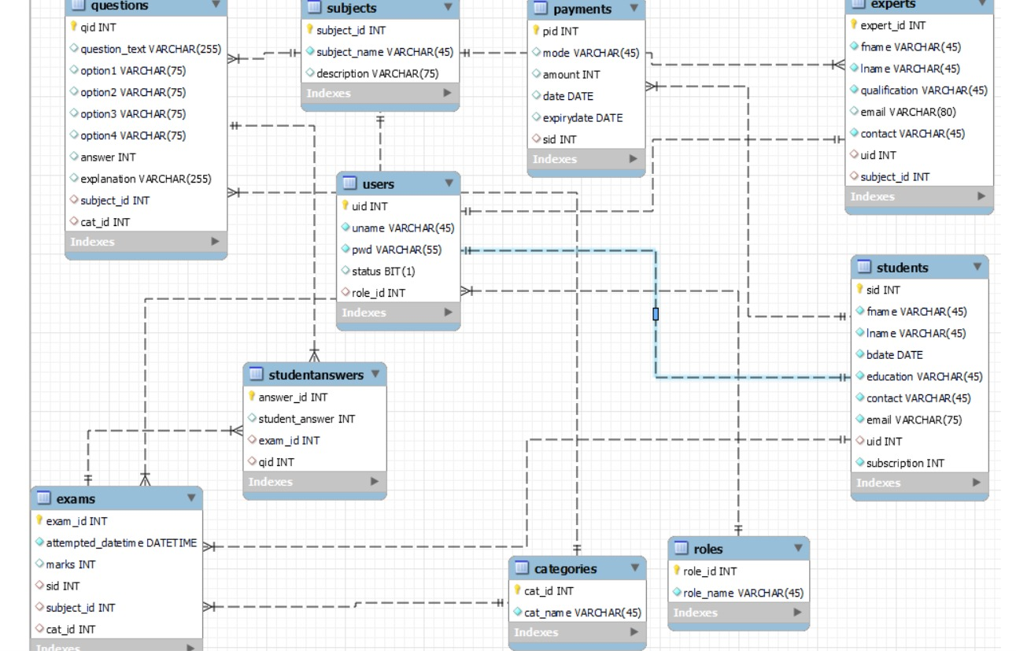

**ER- Diagram shows database of quiz master**

# Snapshots:-

# 1 Login page:

# 

## Registration Page:

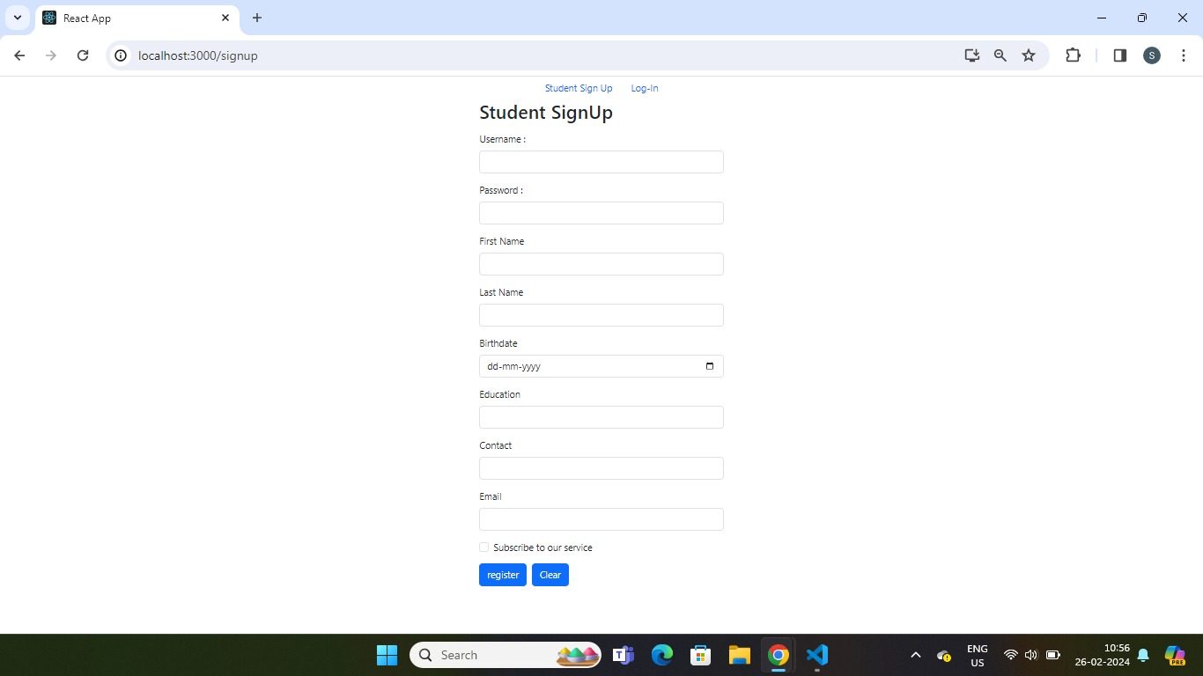

## Admin Home Page:

1.1] Admin home page to manage account

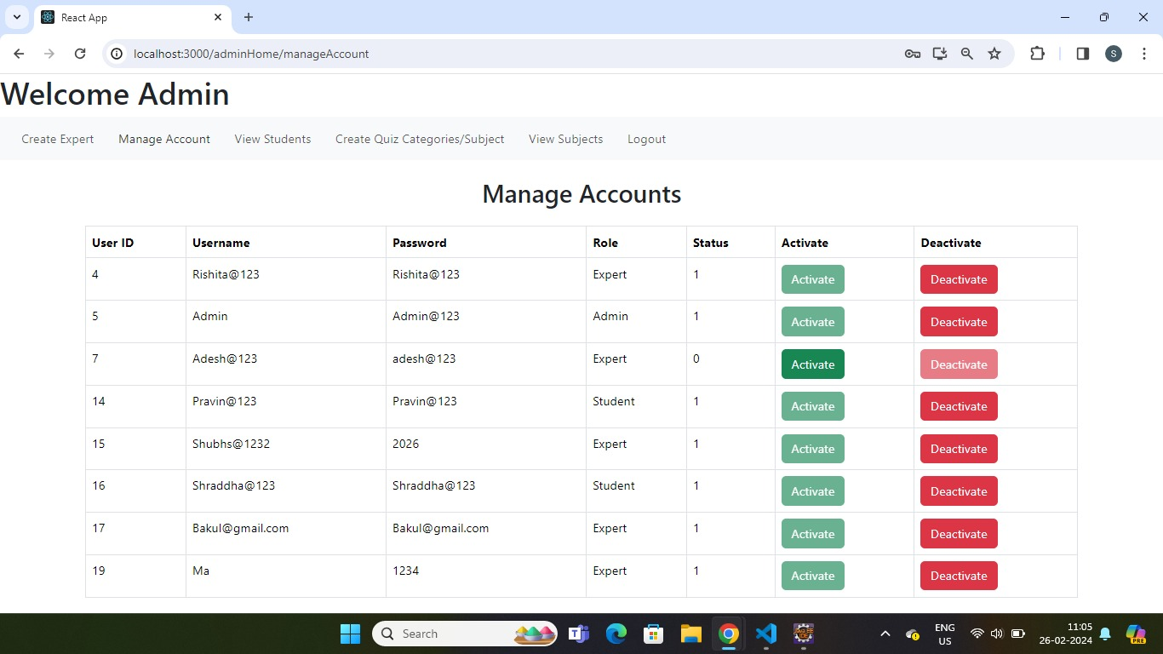

1.2] Admin page to add subjects and create category:-

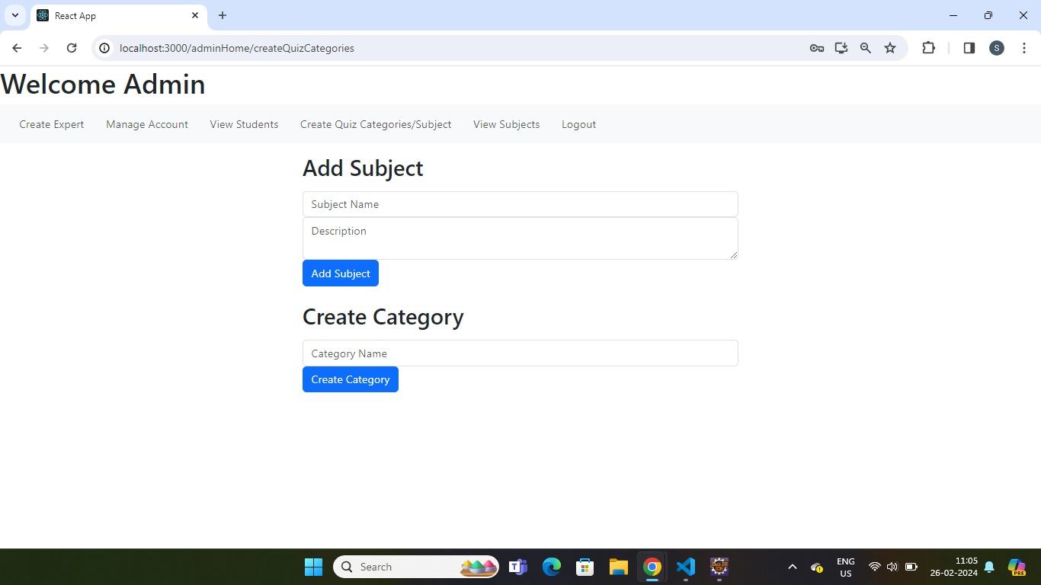

## Admin Page :-

1.3] Admin page to show all subjects:-

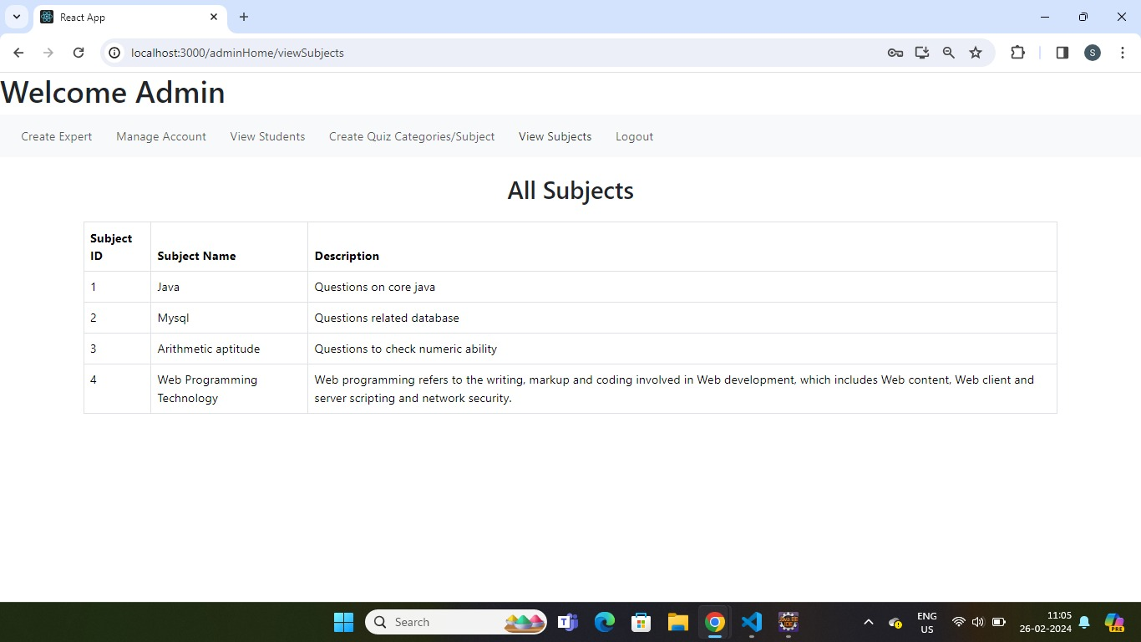

## Expert Page :-

Expert Page to add questions:

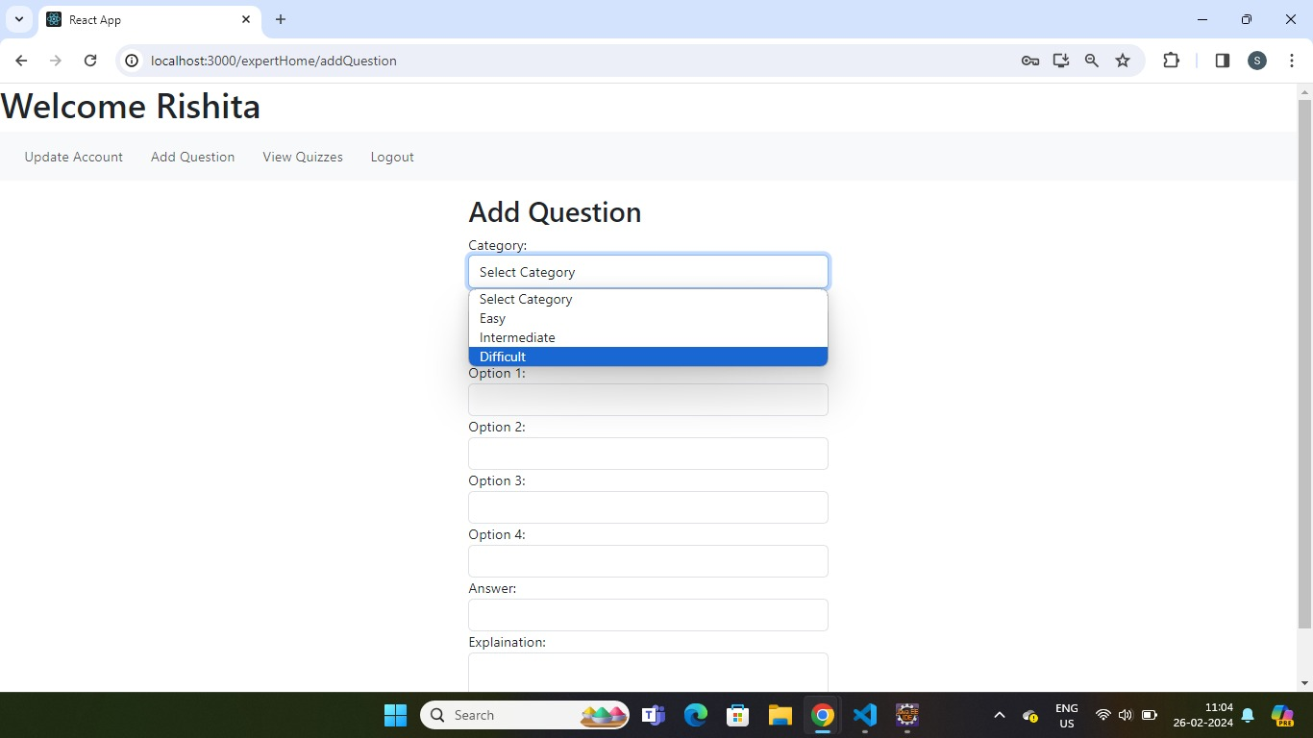

**8.3.1] Expert page**

This page shows quizzes by category

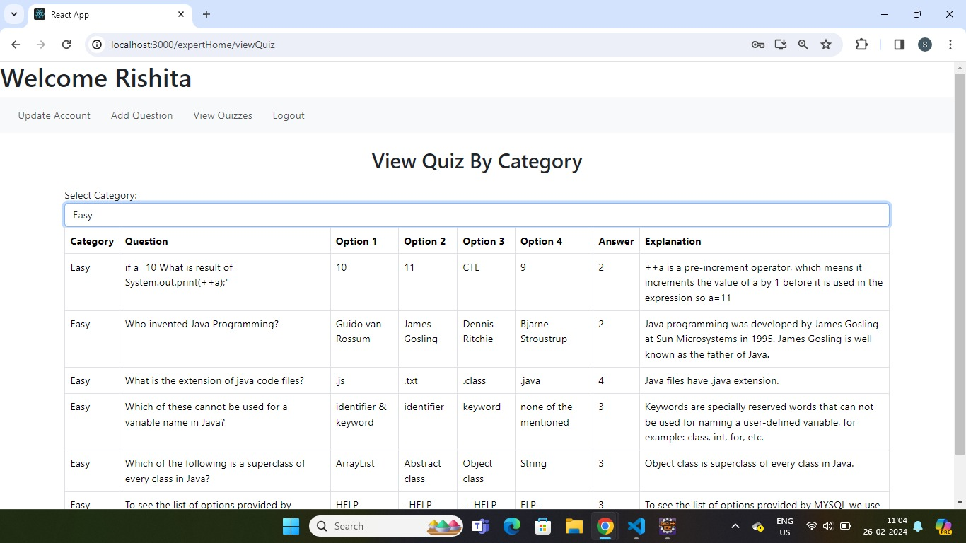

## 8.4 Student Page

Student update page

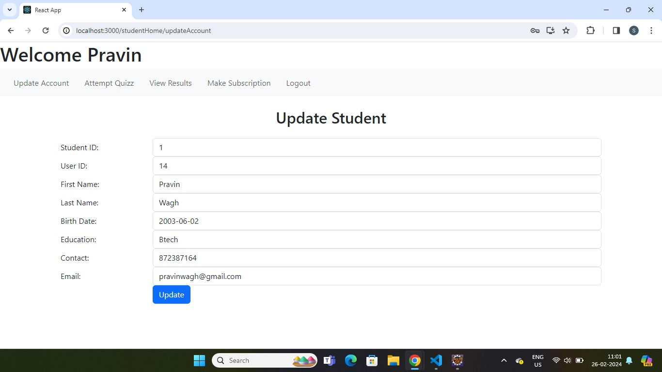

Student Exam Page to shows questions:

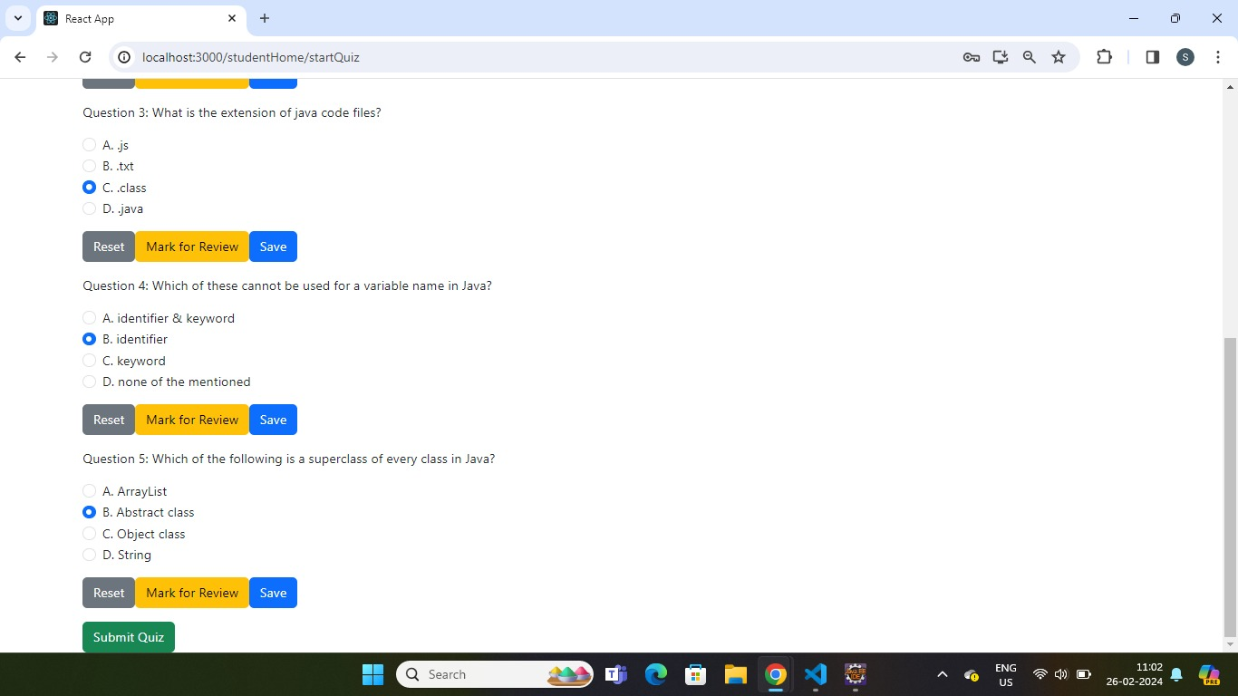

**8.5 Students result page:**

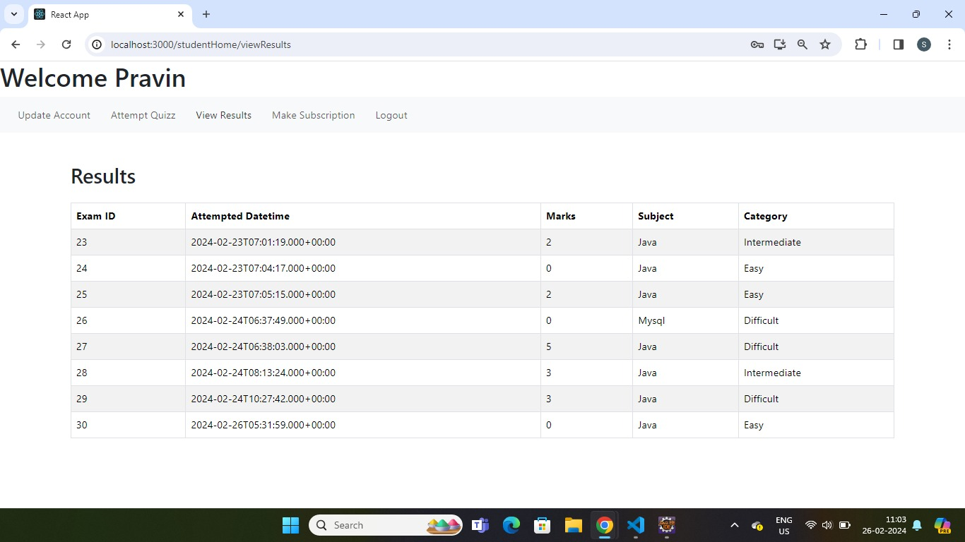

**8.6] Student Subscription page:-**

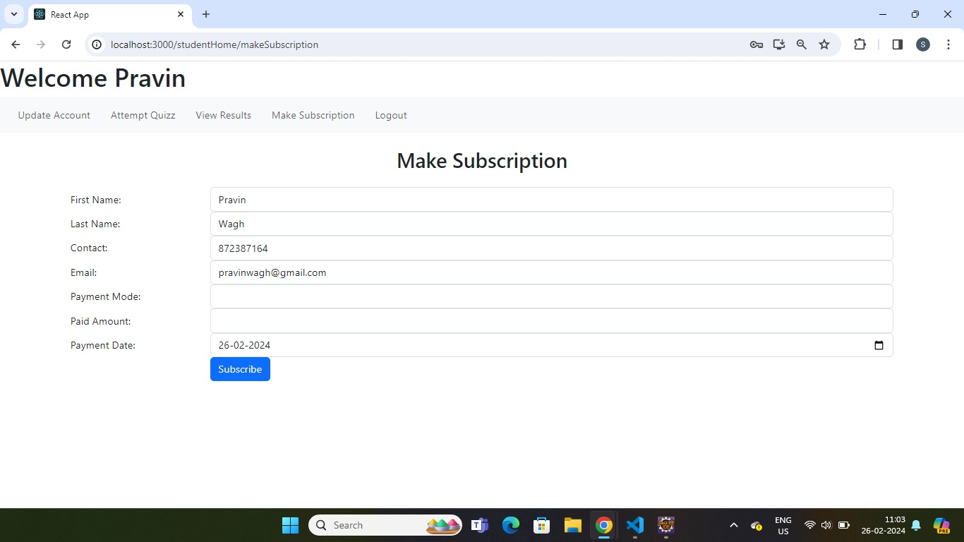

## CONCLUSION AND FUTURE SCOPE

Challenges:

We encountered numerous challenges ,including determining the right path to commence our project ,Time constraint and many more.

Lessons learned:

Throughout the process we learn the valuable insights into effectively distributing tasks within the team and how to integrate diverse technologies to develop a comprehensive software solution.

Overall Experience:

Our journey was marked by practical learning experiences and wealth of knowledge ,contributing significantly to our growth and development.

**FUTURE SCOPE:-**

**Creating Study Groups:**

Students can form study groups within the app. This will allow them to collaborate, share notes, and help each other prepare for quizzes.

Develop features for users to collaborate, discuss, and share knowledge within the platform through forums, chat rooms, and social networking functionalities.

**Gamification and Rewards System:**

Gamify the learning experience by introducing features such as badges, points, levels, and rewards for achieving milestones, completing quizzes, and participating in learning challenges. Design engaging competitions, tournaments, and leaderboards to motivate users, foster healthy competition, and increasing active participation in the platform